Photography II :: Exam: Review

There are 75 multiple choice and true/false questions. Choose the best answer for each question or statement.

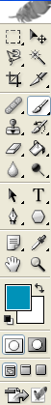
Refer to the diagram to answer the following questions. 1-6

- Which tool allows you to move or transform an image?
1
2

3
4

5
6
- Which tool allows you to crop an image?
7

8

9
- Which tool allows you to enlarge an image for easier viewing?
100

110

120
- Which tool indicates the chosen foreground color?
130

- Which tool indicates the chosen background color?

- Which tool indicates the healing brush?

- A photograph that is taken disregarding composition is most likely referred to as:

- The term photography comes from two Greek words that translate to:

- A digital image’s sharpness, amount of fine detail, and pixels per inch is called:

- The smallest picture element in a digital imaging sensor is known as a:

- Aperture is also referred to as:

- What kind of white balance would you use when using studio lights?

- A megapixel is ______________.

- Which aperture setting is the biggest opening?

- Which aperture setting is the smallest opening?

- Which of these shutter speeds is the fastest?

- When painting on a layer mask in Photoshop, black _____________, white _____________.

- What happens if you press the shutter release button halfway?

- This ISO setting will give you finer grain and your camera will be less sensitive to light

- Shutter speeds are measured in

- What happens if you are using a shutter speed below 60 without a tripod?

- What does SLR stand for?

- You are taking photos in a museum without a tripod and cannot use flash – what should you do?

- If you wanted to affect the amount of time light enters the camera, you would adjust this:

- If you wanted to affect the amount of light that enters the camera, you would adjust this:

- What is the instrument located inside the camera that measures light intensity?

- What kind of white balance would you use inside the classroom?

- In what format should you save a photo that you are editing in Photoshop so you can preserve the layers to edit later?

- The arrangement of objects within the frame of a photograph is called:

- CF and SD are types of ____________.

- This type of portrait refers to an image where the person is posed and the face is the predominant element.

- This type of portrait refers to an image where the subject is photographed in their natural environment.

- This type of portrait is taken without a subject expecting or acknowledging the photographer.

Types of Composition: for the following questions, select the type of composition that best fits the description.

- Surface detail of an object.

- Equally weighted objects are placed on each side of a given point creating a composition that is uniform in balance?

- The lighting comes from behind the subject; the subject appears as a plain black shape against a brighter background.

- A line that leads you visually to an object or that leads into the distance creating depth.

- A view of subject matter from above.

- Shooting through something to get the main subject behind it, or surrounded by it.

- Divide the image into an invisible 3x3 grid; subject is placed on or near one of the intersections or along lines.

- One thing in focus, the rest is blurred.

- Same or similar colors to create a mood.

- Subject matter of the photograph is close and fills the entire frame.

- Everything is in focus.

- Curves in a composition that adds a sense of movement to an otherwise static image, or lead the eye.

- When shooting at fast shutter speeds it is necessary to use a tripod.

- When shooting at slow shutter speeds it is necessary to use a tripod.

- The graininess of a photo is affected by the ISO.

- The higher the ISO the less grainy the photo will appear.

- An 8x10 image with a resolution of 72 is big enough to make a high quality print.

- The white balance settings adjusts the graininess of photographs.

Use this diagram to answer questions 52-58

- What is the aperture?
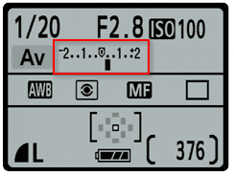

- What is the shutter speed?

- What is the “film” speed?

- What is the camera mode?

- What is the White Balance setting?

- The aperture used will create

- The shutter speed used will create

The following items are in reference to the basic Photoshop workspace.
Document window
Tool bar
Options bar
panels
Application bar

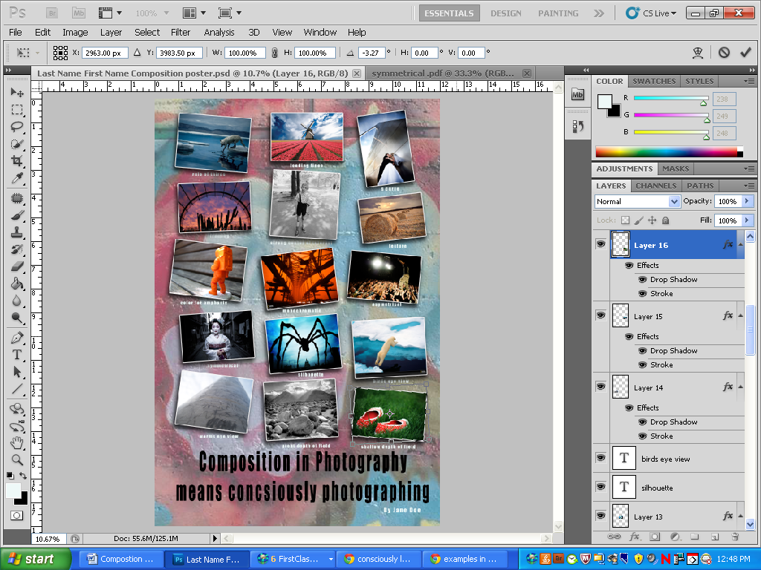

- To create a new Photoshop document, you would start out using functions from this bar:

- If you make a transformation to a photo (change the size or rotation), you can confirm or reject your changes on this bar:
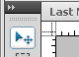

- This tool is called:
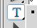
- This tool is called:

- The fx button at the bottom of your layers panel allows you to:

Select the BEST composition type for each photograph.
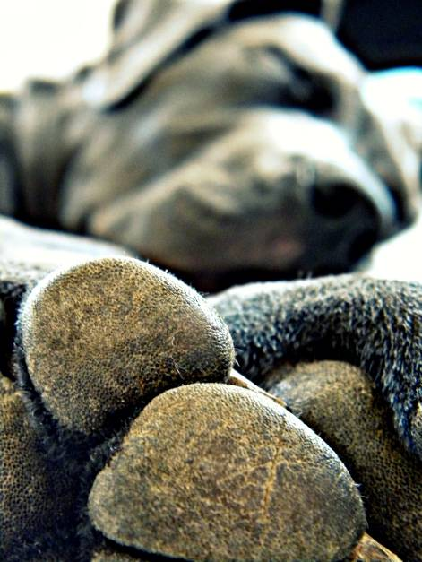
- This photograph is an example of:

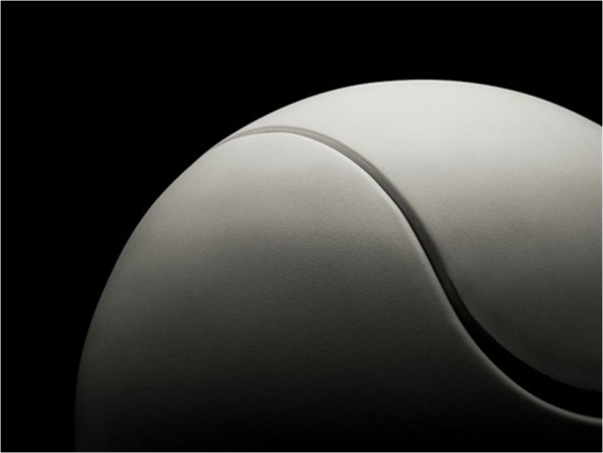
- This photograph is an example of:

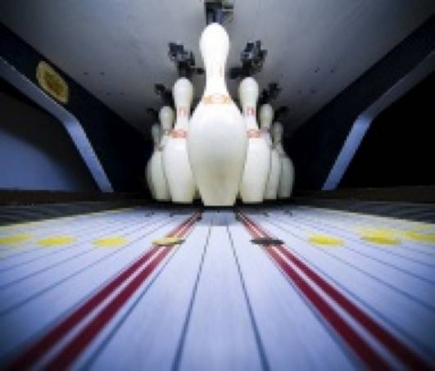
- This photograph is an example of:

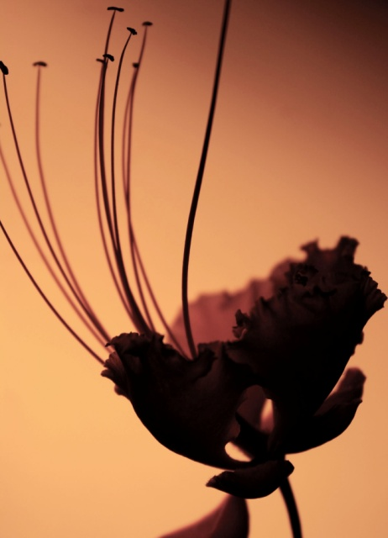
- This photograph is an example of:

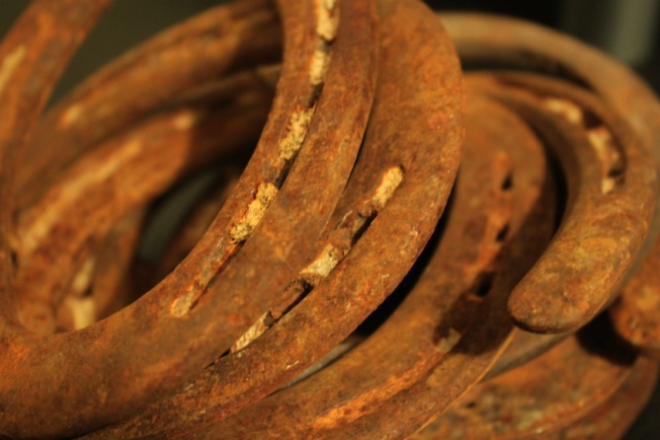
- This photograph is an example of:

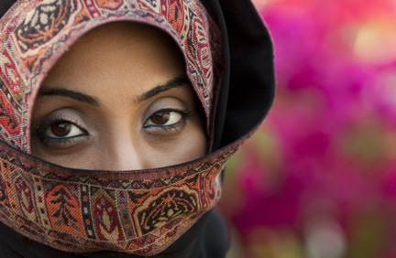
- This photograph is an example of:

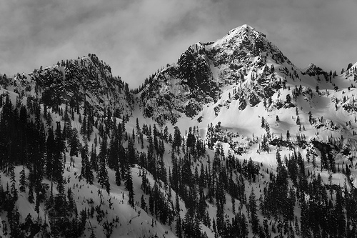
- This photograph is an example of:

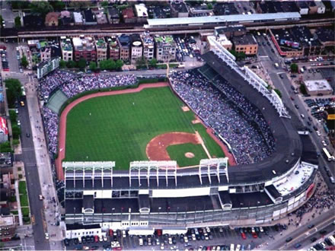
- This photograph is an example of:

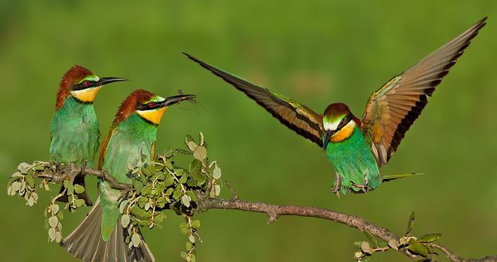
- This photograph is an example of:

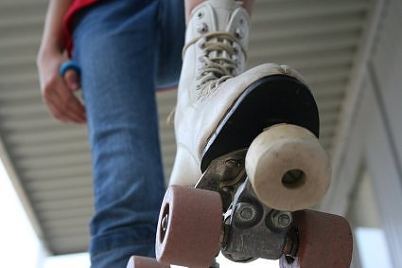
- This photograph is an example of:

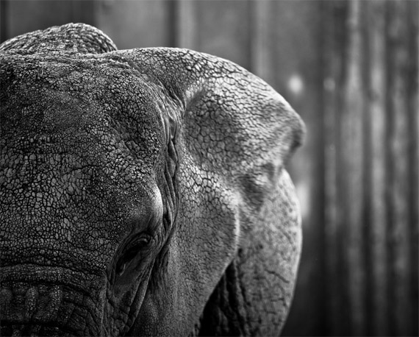
- This photograph is an example of:

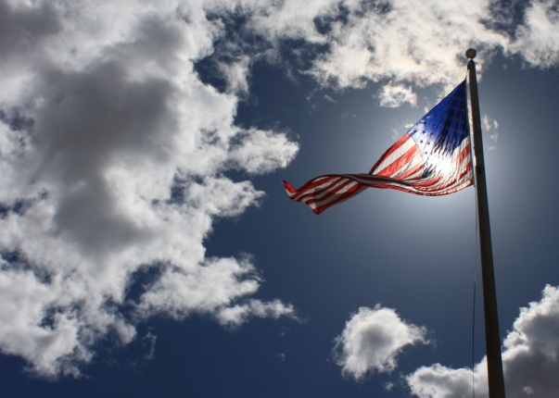
- The orientation of this photo is:

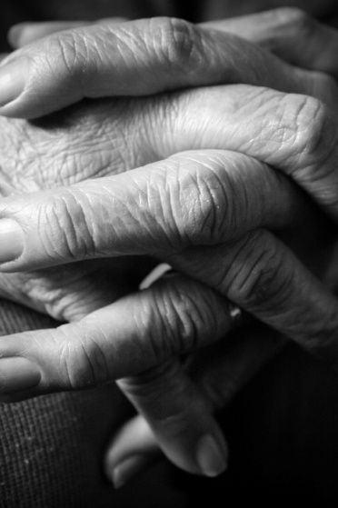
- The orientation of this photo is:

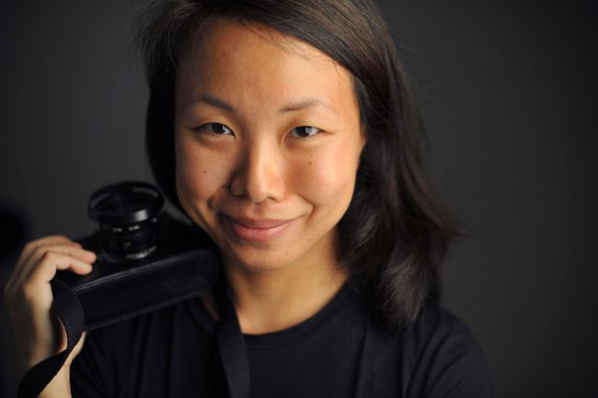
Identify the type of portraits using the corresponding photographs:
- This is an example of a _______________portrait.

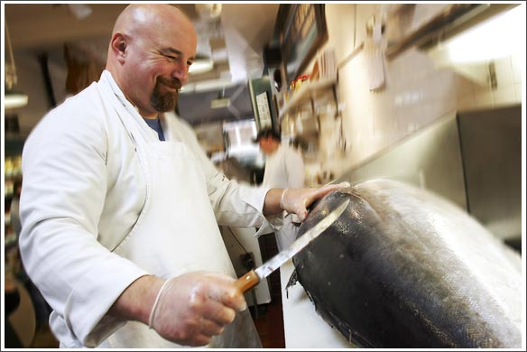
- This is an example of a _______________portrait.

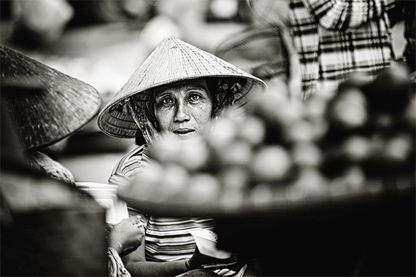
- This is an example of a _______________portrait.

Identify the type of landscape using the corresponding photographs:
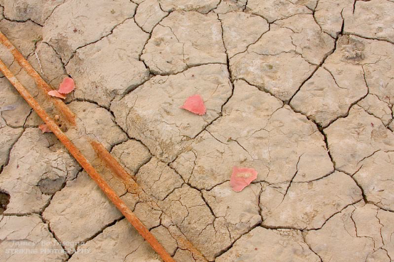
- This is an example of a _______________landscape photograph.

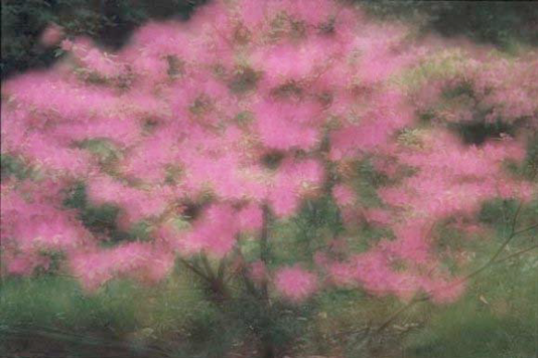

- This is an example of a _______________landscape photograph.

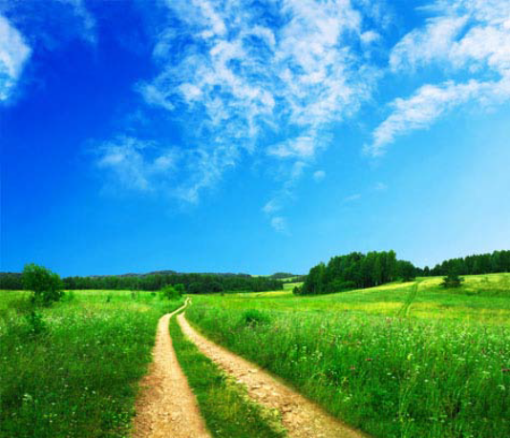
- This is an example of a _______________landscape photograph.

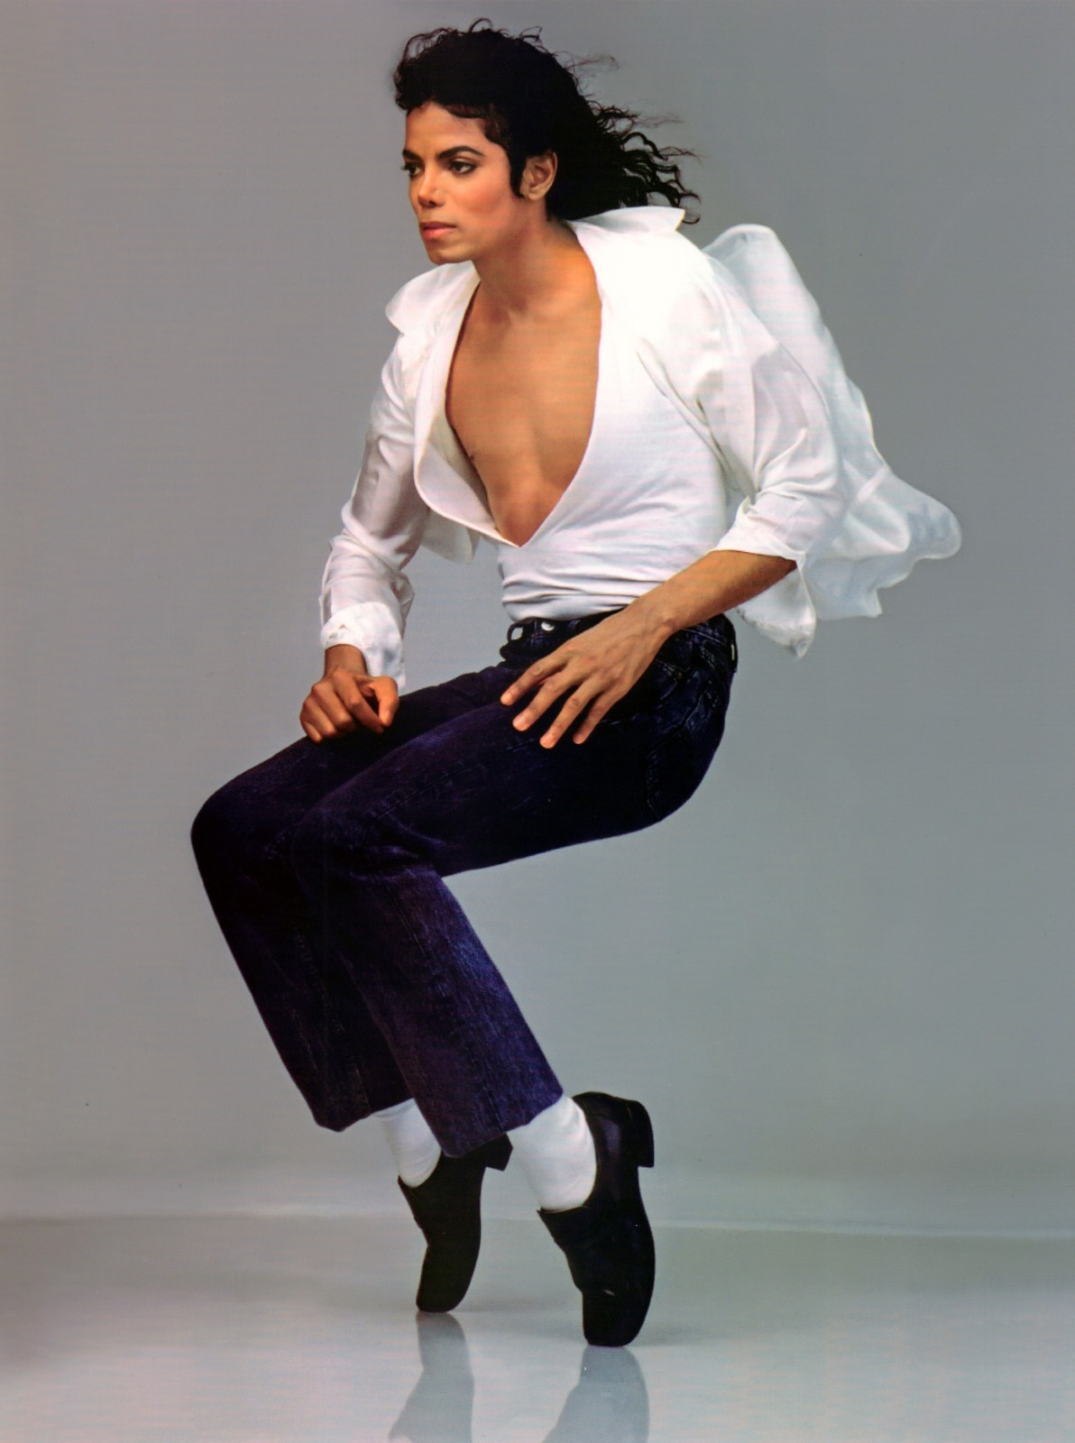
- What shutter speed was MOST LIKELY used to take this photo:

- What shutter speed was MOST LIKELY used to take this photo:

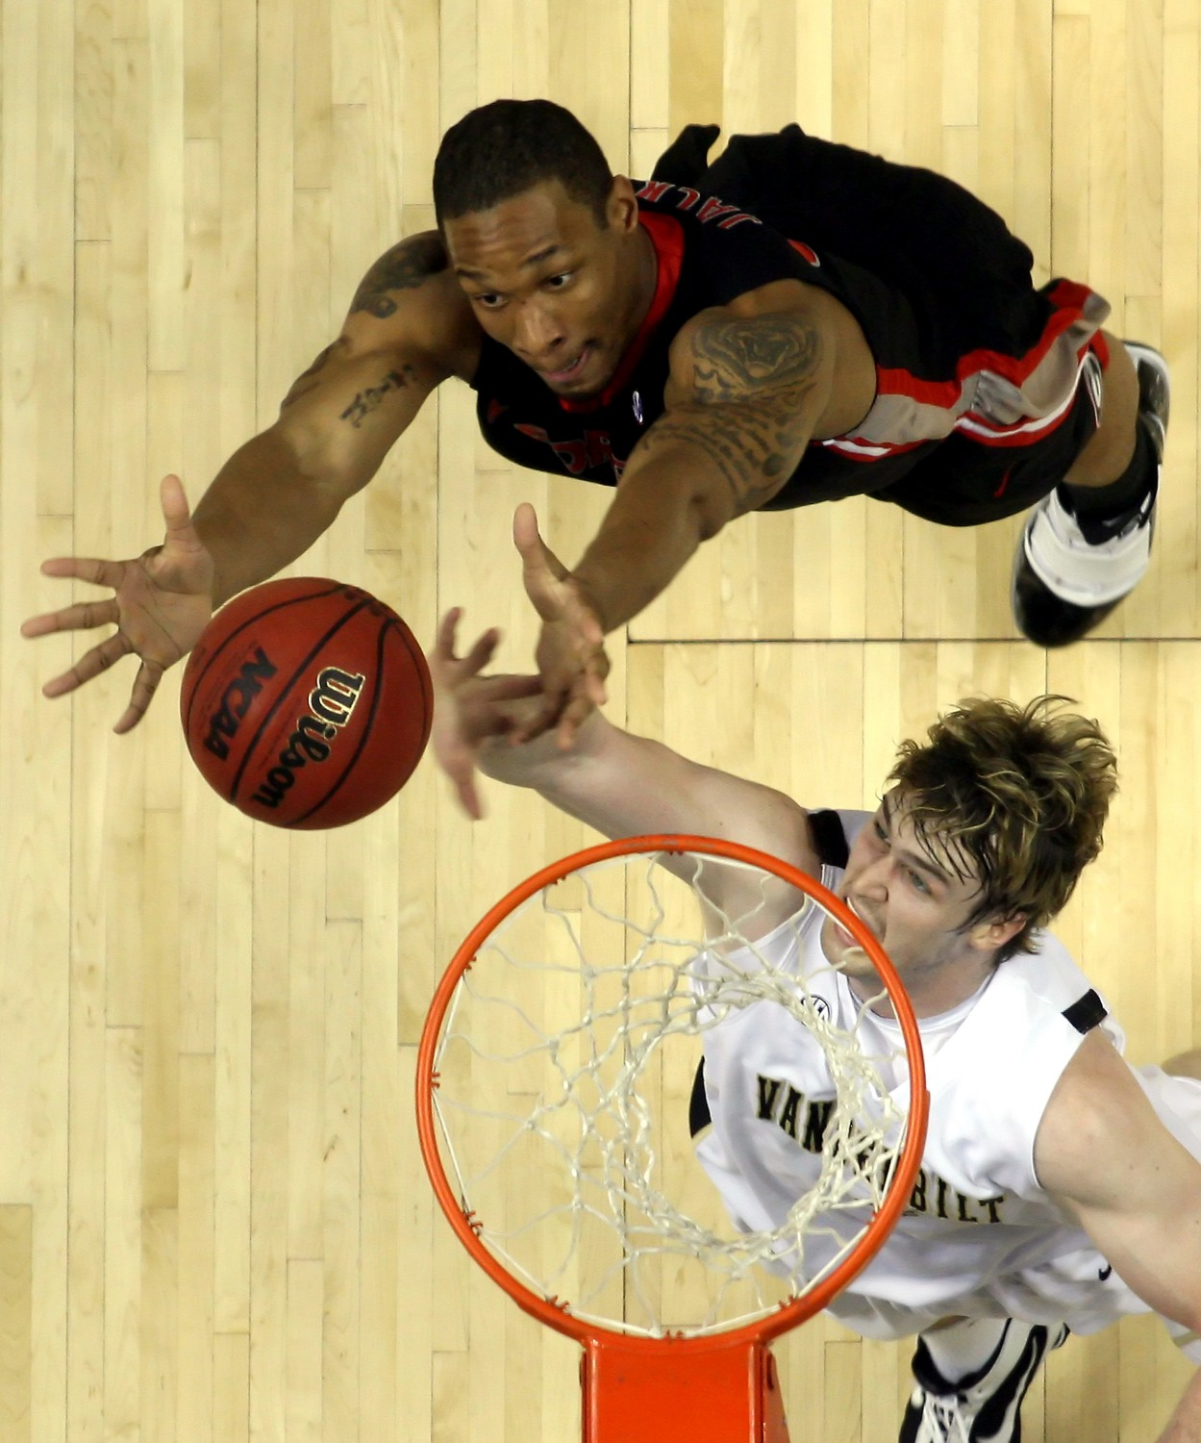

- What shutter speed was MOST LIKELY used to take this photo:


